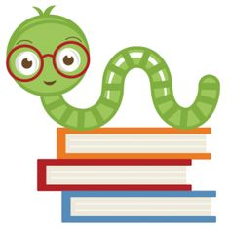

**Specials Classes:**

**Spanish (Monday):** Exposing the students to the Spanish language. The students will be learning about family members and household items in Spanish.

**Computers (Tuesday):** Emphasize proper hand placement showing which fingers are responsible for which keys on the keyboard.

**Gym (Friday):** Finishing up with MCA Olympics and starting kickball activity mid-March.

**Reminders:**

* Please help students:
  + practice their spelling words every night.
  + complete Reading Logs and bring them in every Friday.
  + **remember their take home folders every day.**
  + use the bathroom every morning before coming to school.
* Dress in layers, bring coats and sweaters for winter temperatures.

**No School Friday, March 5th:** Teacher In-Service

**What we are learning:**

**Language Arts:**

Target Skill: Show comprehension about what was read, identify main ideas of a story. Using problem solving abilities by finishing the story based off context clues.

Spelling: Spell words using syllable rules. Apply use of root word, suffixes, and prefixes.

**Writing**:

Focus Trait: Apply phonics rules to complete dictation. Construct complete sentences with appropriate capitalization and punctuation.

**Math**:

-Two-digit addition and subtraction.

-Problem Solving. Related Facts

**Science**:

Mystery Science. Epic Book Materials

**History:**

My America and My World

First Grade Goal Sheet

Mrs. Ferren

1stferren@mcaschools.org

March 2021

**Following Jesus:**

**Bible**: Purposeful Design – God’s Written Word, Following Jesus, Loving Others

**Chapel**: “Learning to Follow Jesus”

Attribute #5 “Learn to Influence”.

**Scripture Verse:** Matthew 28:18-20