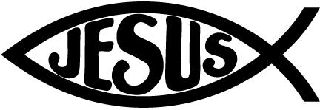

**Reminders:**

Please ‘turn in’ homework by sending a photo of completed work to 2nd3rdDierkes@mcaschools.org

Check Google Classroom

Please set alerts for Google Classroom Posts!

Please remember to check your child’s take-home folder every night.

Please remember to send in an extra clean mask.

November 5th-6th **NO SCHOOL** Staff-In-Service

November 18th Picture Make up Day (Students should be in Full uniform)

November 24th Tuesday, Thanksgiving Virtual Chapel

November 25th – 27th Thanksgiving Break

**Specials Classes:**

**Computers (Monday):** Internet Safety-: Learn what information is appropriate to put on the web and how to safely use the internet and apps.

**Spanish (Tuesday):** Exposing students to the Spanish language. The students will learn the colors, fruits, and vegetables in Spanish.

**Gym (Friday):** The Students will learn basketball skills.

**What we are learning:**

**Language Arts:**

Anchor Texts: *Dogs, Helping Paws, Diary of a Spider, A Swallow and a Spider, Destiny’s Gift*

**Target Comprehension Skill:** Author's Purpose, Compare and Contrast

**Target Comprehension Strategy:** Analyze/Evaluate, How to Analyze the Text

**Vocabulary Strategy**: Multiple meaning words,

Antonyms

**Grammar:** Types of Sentences, Compound Sentences

**Spelling**: Long a and Long e Spellings

**Phonics:** Common Vowel Pairs ai, ay, ee, ea

**Writing**: Narrative Writing, Sentences that describe, Personal Paragraph, Focus Trait: Voice

**Math**: Represent and Interpret Data, Solve problems involving the four operations, and identify and explain patterns in arithmetic.

**Science**: Animals Through Time

Animal Survival & Heredity

**Social Studies: John Smith, Pocahontas**

Second Grade Goal Sheet

Miss Dierkes

2nd3rdDierkes@mcaschools.org

November 2020

**Following Jesus:**

**Bible**: Abraham Prays for Lot, How to Pray, Interceding for Others, God Responds to Prayer

**Chapel Attribute 2**: Learn to Listen

**Scripture Verse: Matthew 7:24-25**