PREK-4’S

April 2020

Bible: Qq Walking Patterns Queen, Quilt, Quiet,
Resurrection, 61-70 Backward & Question Mark, Quail,
Jesus Is Alive, Orange - anaranjado Size Order Q-Tip, Quarter, Quest,
& Returns to Quick Sand, Quinoa
Heaven

Bible: Aa, Bb, Cc Bunny Hop Fruits of the Apron, Ape, Angel, Aid,
Easter Story Long “A” Spirit April, Ate, Airplane
71 – 80 Balloons, Balls, Bears Cookies, Cats, Cars, Cows

E A S T E R B R E A K — M C A C L O S E D

Bible: Dd, Ee, Ff Exercise Fruits of the Dogs, Dinos, Dolls, Doctor
Feeding the Long “E” Spirit Ears, Eat, Easel, Eagle, Eel,
5,000 81 – 90 Email, Equal, Even
Flowers, Firefighter, Fish

Bible: Gg, Hh, Ii Galloping Graphing Goop, Groceries, Garage
Jesus Walks Long “I” Horse, Hat, House, Helper
on Water 91 – 100 Ice, Iron, Island, Ice Cream,
Iced Tea, Ice Skates, Ivy

Sun | Mon | Tues | Wed | Thurs | Fri | Sat
MAG Church Services:  Wed. 7 pm  Sat. 6 pm  Sun. 9 am &  10:45 am |  |  | 1 | 2 | 3 | 4
5 | 6 | 7 | 8 | 9 | 10  Good Friday! | 11
12 | 13 | 14 | 15 | 16 | 17 | 18
19 | 20 | 21 | 22 | 23 | 24 | 25
26 | 27 | 28 | 29 | 30
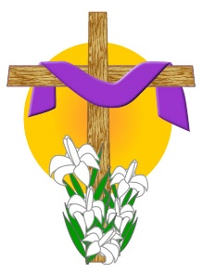 |  |  | 