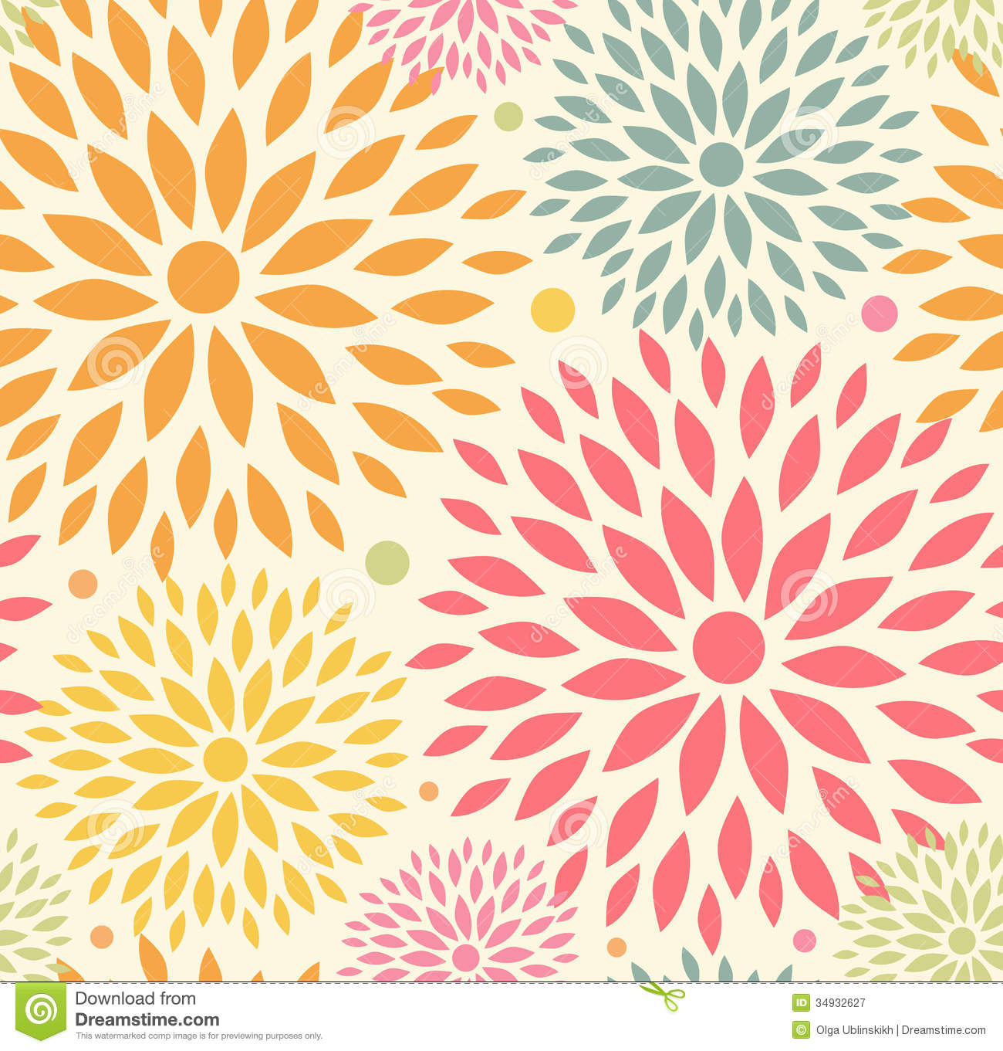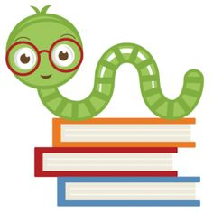

**Reminders:**

Please remember to check your child’s folder.

Please make sure your child is dressed appropriately for the weather to ensure that they can go outside for recess.

**No School Friday, March 5th:** Teacher In-Service

**Specials Classes:**

**Spanish (Monday):** Exposing the students to the Spanish language. The students will be learning about family members and household items in Spanish.

**Computers (Tuesday):** Emphasize proper hand placement showing which fingers are responsible for which keys on the keyboard.

**Gym (Friday):** Finishing up with MCA Olympics and starting kickball activity mid-March.

**Following Jesus:**

**Bible**: The Lord’s Prayer

**Bible Verse:** Matthew 6:9-13

**Chapel**: “Learning to Follow Jesus”

Attribute #5 “Learn to Influence.”

**Scripture Verse:** Matthew 28:18-20

**What we are learning:**

**Reading:** Short vowels, Long vowels, reading groups, reading fluently and with expression, Spelling words

**Writing**: Creating sentences, using spelling words in sentences, and using correct spacing between words

**Math**: Chapter 10 - *Identify and Describe Three-Dimensional Shapes,* positional words

**Science**: Forces, Machines, and Engineering; Plants

**Social Studies:** We will continue our “tour” around the world. We will be learning about other cultures. We will be talking about how God loves all the children of the world.

Kindergarten II Goal Sheet

Ms. Smith

k2smith@mcaschools.org

March 2021