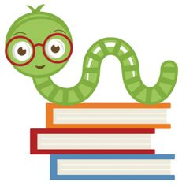

**Reminders:**

Homework assigned Monday, Tuesday, and Thursday. All homework must be posted to google classroom.

**No School Friday, March 5th:** Teacher In-Service

**Specials Classes:**

**Spanish (Monday):** Exposing the students to the Spanish language. The students will be learning about family members and household items in Spanish.

**Computers (Tuesday):** Emphasize proper hand placement showing which fingers are responsible for which keys on the keyboard.

**Gym (Friday):** Finishing up with MCA Olympics and starting kickball activity mid-March.

**What we are learning:**

**Language Arts:** Journeys

**Anchor Texts:** Jose! Born to Dance.

**Target Skill:** Author’s purpose, simile, and metaphor

**Grammar:** Direct Quotations and Interjections

**Spelling:** Schwa + /r/ sounds

**Writing**: Explanatory Essay

**Focus Trait:** Word Choice

**Math**: Estimate and divide with 2-Digit Divisors

**Science**: This month in science 4th and 5th grade will be continuing to work on the unit Chemical Magic, Chemical Reactions & Properties of Matter.

**Social Studies:** This month 5th grade History will be completing and presenting their Country Research Projects. As well we will start studying Egypt and surrounding countries. In Geography we will continue to study the bodies of water and landforms in Europe, Africa, and Asia

Fifth Grade Goal Sheet

Ms. Okan

4th5thokan@mcaschools.org

March 2021

**Following Jesus:**

**Bible**: Stewardship, Jesus’ First Miracle

Memory Verses: 1 Corinthians 4:2, John 2:11

**Chapel**: “Learning to Follow Jesus”

Attribute #5 “Learn to Influence.”

**Scripture Verse:** Matthew 28:18-20