Marlton Christian Academy | 625 East Main Street  mcaschools.org  856. 988.8503
Dear MCA Family, March is a wonderful month known for coming “in like a lion and out like a lamb”. We look forward to Spring.

2021-2022 Registration Update - Thank you for enrolling early for 2021-2022. It helps us so much in planning and preparing for the new school year. Please help us by updating any changes to your enrollment as soon as possible. Our Open Houses have been very fruitful! We look forward to a wonderful new school year. Please continue to share our school on social media with friends, family, and prospective new students who would be blessed by MCA’s Christian values and strong academics.
Staff In-Service - Friday, March 5th, MCA will be closed. Thank you for helping us to be our best for your students!
Dr. Suess Virtual In-House Field Trip – In lieu of our yearly Barnes and Noble Family Night, this month we will enjoy a special virtual Field Trip that will highlight our love of books and reading!
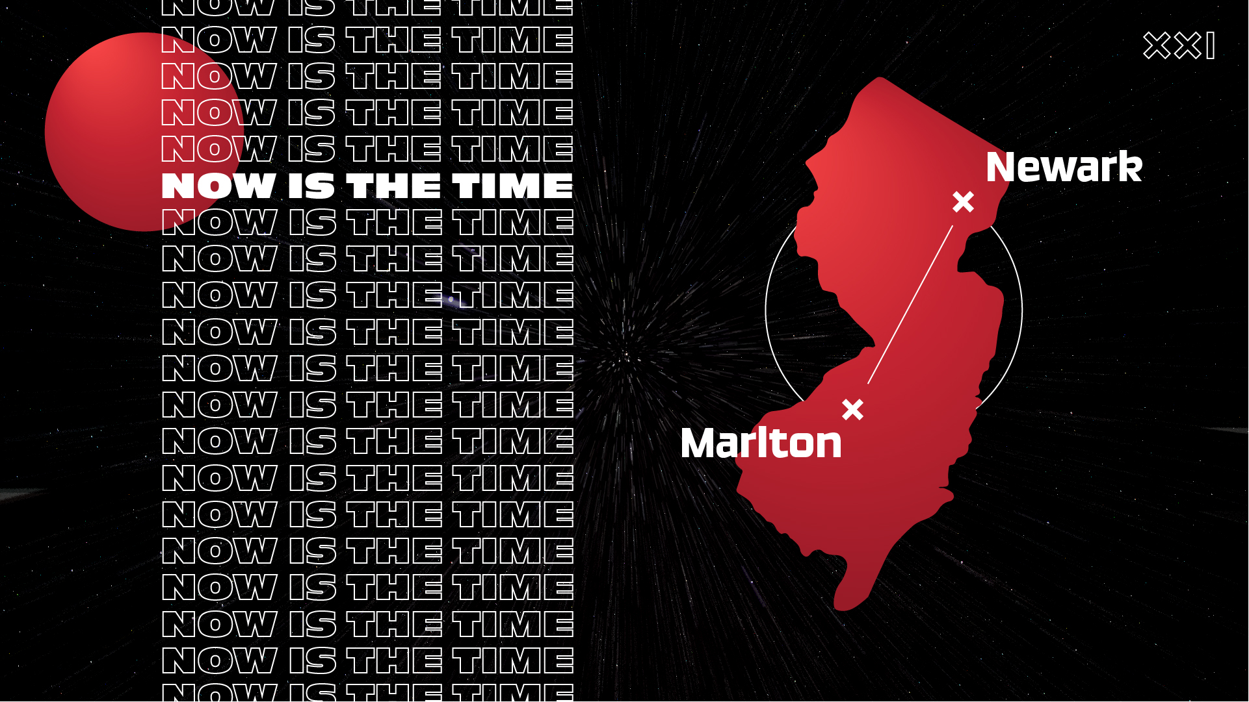
What’s Happening at Marlton Assembly of God:
As always, you are welcome to join us at MAG in-person or online as Pastor Jon transitions from our sermon series on "I Will Build My Church" and moves into “Now is the Time”. As of Sunday, February 28th, we are now ONE church in TWO locations! We look forward to all God has and how He continues to use our church to reach NJ and the world!! Join us as we go to Newark, NJ to help Vailsburg Assembly of God with some rehab projects in and around their church building. Projects include Painting, Power Washing, Electric, Plumbing and General Cleaning. For more information or to sign up, please click the link marltonag.org #NOWISTHETIME

All God’s Best,
Miriam R. Wegner
MARCH 2021

All God’s Best,
Miriam R. Wegner, Principal

Sunday | Monday | Tuesday | Wednesday | Thursday | Friday | Saturday
 | 1 | 2 | Open House 9am  United Prayer Service  7pm | 4 | 5  Teachers  In-service  School Closed | 6
7  MAG Services  9am & 11am | 8 | 9 | 10  United Prayer Service  7pm | 11 | 12 | 13
14  MAG Services  9am & 11am | 15 | 16 | 17  United Prayer Service  7pm | 18 | 19 | 20
21  MAG Services  9am & 11am | 22 | 23 | 24  United Prayer Service  7pm | 25 | 26 | 27
28  MAG Services  9am & 11am | 29 | 30 | 31  United Prayer Service  7pm

