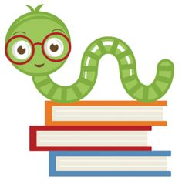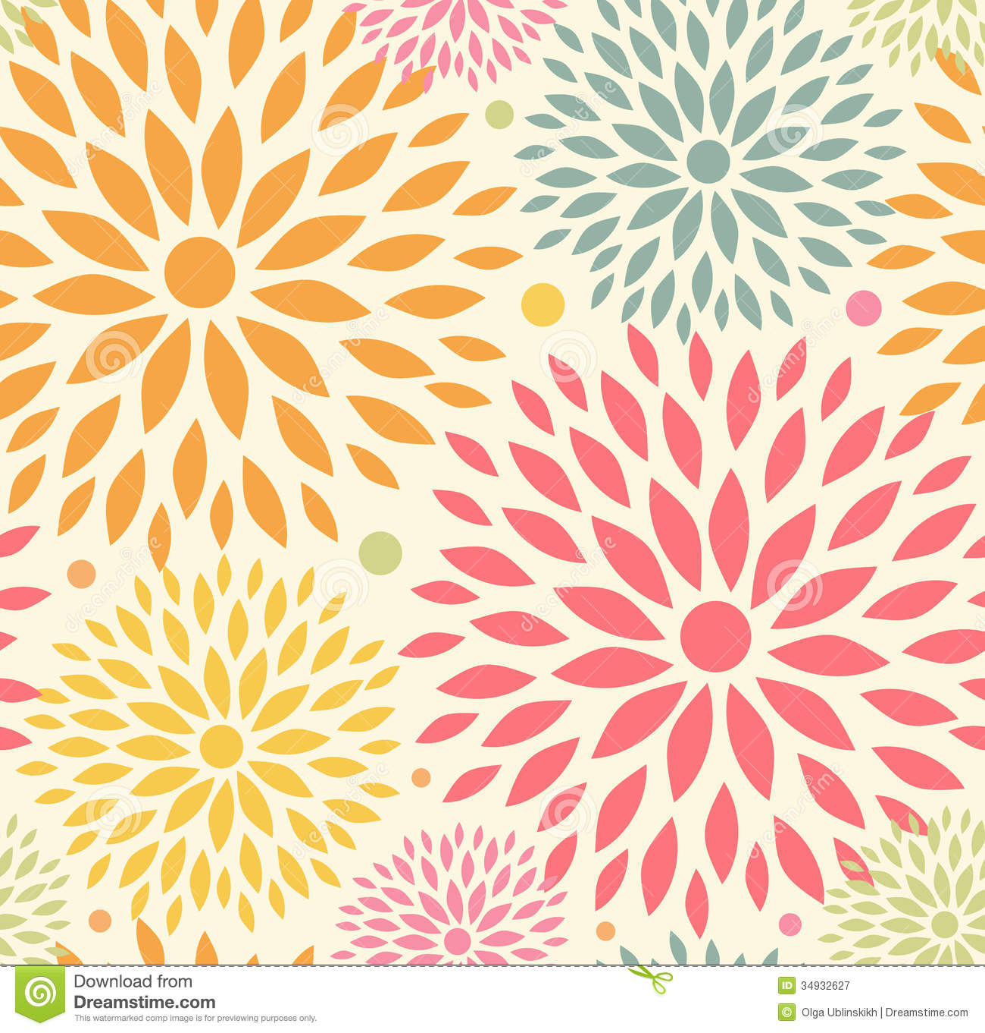

**Specials Classes:**

**Computers (Monday):** Internet Safety-: Learn what information is appropriate to put on the web and how to safely use the internet and apps.

**Spanish (Tuesday):** Exposing students to the Spanish language. The students will learn the colors, fruits, and vegetables in Spanish.

**Gym (Friday):** The Students will learn basketball skills.

**Reminders:**

Please remember to check your child’s take-home folder every night.

Please set alerts for Google Classroom Posts!

Please remember to send in an extra clean mask.

November 5th-6th **NO SCHOOL** Staff-In-Service

November 18th Picture Make up Day (Students should be in Full uniform)

November 24th Tuesday, Thanksgiving Virtual Chapel

November 25th – 27th Thanksgiving Break

**What we are learning:**

**Language Arts:**

Identify Letter and Sounds, Review Vowels, Blends, Decoding

Grammar: Alphabetical Order, Multiple Meaning Words

Spelling: Short and Long Vowel Sounds, Vowel Patterns, Blends

**Writing**: Subject, Predicate, Types of Sentences, Story Structure

**Math**: Addition and Subtraction Strategies, Problem Solving

**Science**: Mystery Science – Plants, Environment, Solar System

**Social Studies: Map Skills, America’s Founders, Pilgrims, Native Americans, Thanksgiving**

1st Grade Goal Sheet

Mrs. Ferren

1stferren@mcaschools.org

November 2020

**Following Jesus:**

**Bible**: Purposeful Design - Moses

**Chapel**: Attribute 2 “Learning to Listen”

**Scripture Verse:** Matthew 7:24-25