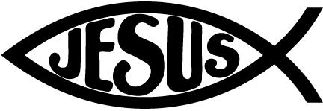

**Following Jesus:**

**Bible**: Ruth Serves with Love, David Faces the Giant, Elijah Trusts God

**Chapel**: Attribute 6 “Learn to Pray”

**Scripture Verse: Matthew 6:9-13**

**Specials Classes:**

**Spanish (Monday):** Exposing the students to the Spanish language. The students will be learning feelings and adjectives in Spanish.

**Computers (Tuesday):** Continue emphasizing proper hand placement showing which fingers are responsible for which keys on the keyboard.

**Gym (Friday):** Students will learn teamwork, and cooperation along with the skill to play Flag Football.

**Reminders:**

Please send Homework to 3rdDierkes@mcaschools.org or post on our Google Classroom

Please make sure your child still has plenty of extra masks!

**Easter Break – No School 4/2-4/11**