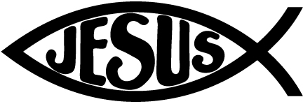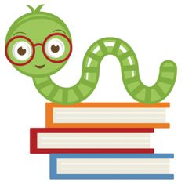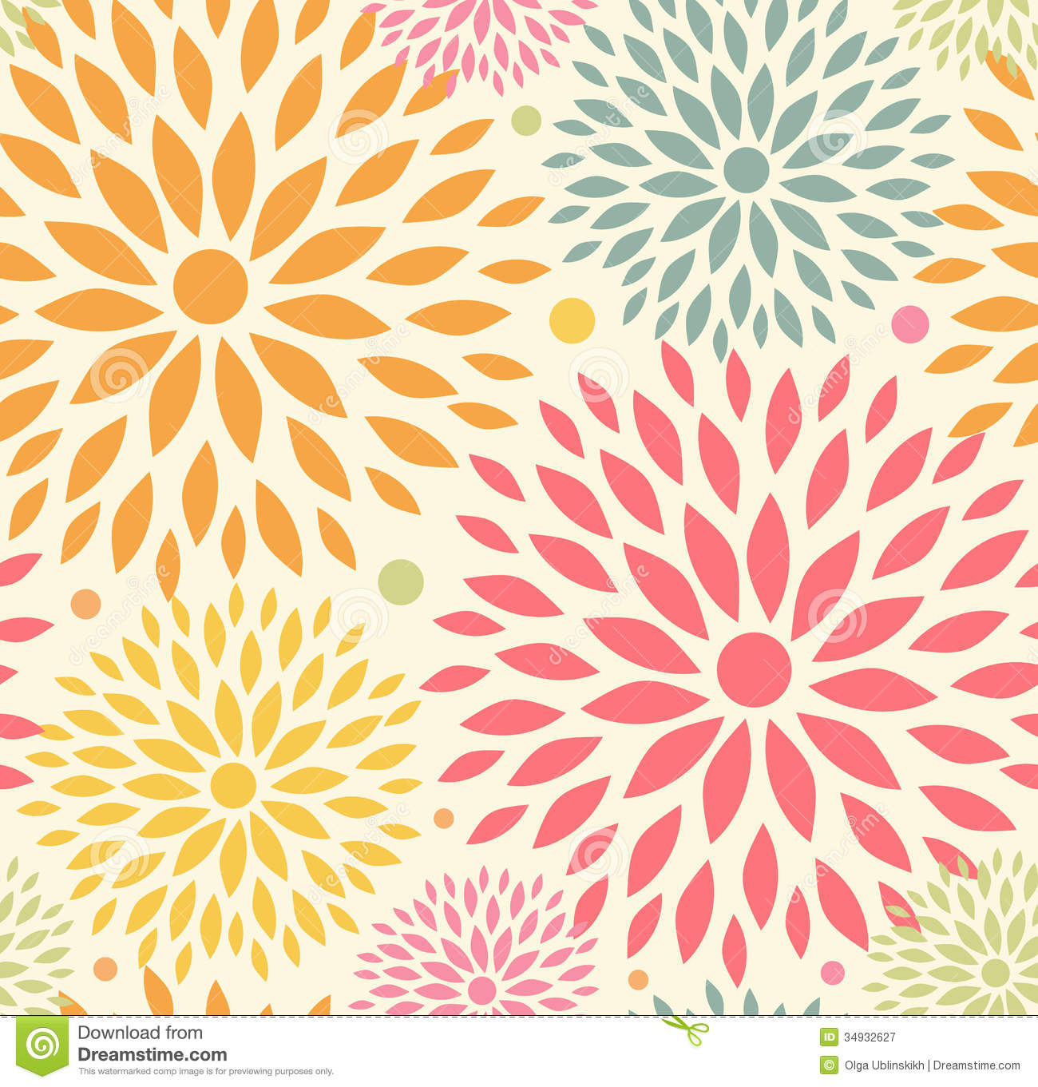

**Reminders:**

Please remember to send in an extra clean mask.

Make sure that you are checking your student’s take home folder on Friday night.

November 5th-6th **NO SCHOOL** Staff-In-Service

November 18th Picture Make up Day (Students should be in Full uniform)

November 24th Tuesday, Thanksgiving Virtual Chapel

November 25th – 27th Thanksgiving Break

**Specials Classes:**

**Computers (Monday):** Internet Safety Learn what information is appropriate to put on the web and how to safely use the internet and apps.

**Spanish (Tuesday):** Exposing students to the Spanish language. The students will learn the colors, fruits, and vegetables in Spanish.

**Gym (Friday):** The Students will learn basketball skills.

**What we are learning:**

**Reading:** Short Vowels, Blends, Letters Y, Y, P, X, Z, and Q.

**Writing**: Letters Y, P, X, Z, and Q, spacing between words.

**Math**: Chapter 4 – Represent and Compare Numbers to 10, Chapter 7 – Represent, Count, and Write 11 to 19

**Science**: Weather, 5 Senses

**Social Studies:** Community Helpers: Bakers, Veterinarians, Salespeople, What Do I Want To Be When I Grow UP, and Pilgrims/Thanksgiving

Kindergarten III Goal Sheet

Ms. Approvato

K3approvato@mcaschools.org

November 2020

**Following Jesus:**

**Bible**: Young Samuel, Samuel Anoints Two Kings, Thanksgiving

**Chapel Attribute 2**: Learn to Listen

**Scripture Verse:** Matthew 7:24-25