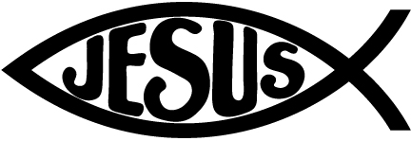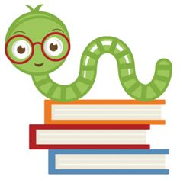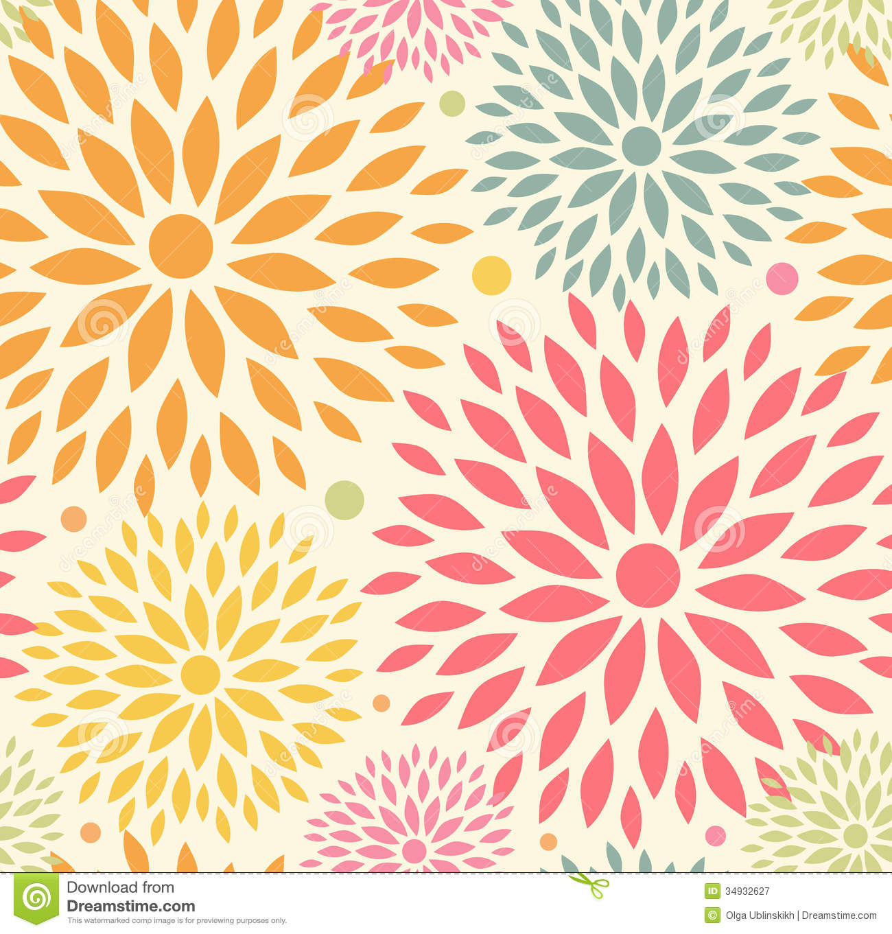

**Reminders:**

Homework is given every Monday, Thursday and Friday unless otherwise indicated.

All homework must be posted to google classroom.

Please ‘turn in’ homework by sending a photo of completed work to 4th5thokan@mcaschools.org

Check Google Classroom

Please set alerts for Google Classroom Posts!

Please remember to send in an extra clean mask.

November 5th-6th **NO SCHOOL** Staff-In-Service

November 18th Picture Make up Day (Students should be in Full uniform)

November 24th Tuesday, Thanksgiving Virtual Chapel

November 25th – 27th Thanksgiving Break

**Specials Classes:**

**Computers (Monday):** Internet Safety: Learn what information is appropriate to put on the web and how to safely use the internet and apps.

**Spanish (Tuesday):** Exposing students to the Spanish language. The students will learn the colors, fruits, and vegetables in Spanish.

**Gym (Friday):** The Students will learn basketball skills

**Following Jesus:**

**Bible**: Equipping the Disciples

**Bible Verse**: Luke 6:40

**Chapel Attribute 2**: Learn to Listen

**Scripture Verse: Matthew 7:24-25**

**What we are learning:**

**Language Arts: Journeys**

**Anchor Texts:** The Librarian is a Camel

**Target Skill:** Identify cause and effect relationships in text

**Grammar**: to use commas and quotation marks, quotations from text.

**Spelling**: Words that have short i and long i sounds.

Phonics: Decode words with open and closed syllables

**Writing**: Narrative

Focus Trait: How to write a dialogue

**Math**: Go Math: Add and subtract whole numbers

**Science**: Mysteryscience.com: What do plants eat? what makes roller coasters go so fast?

**Social Studies:** The History of our United States: Years of Exploration

Fourth Grade Goal Sheet

Ms. Okan

4th5thokan@mcaschools.org

November 2020