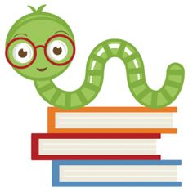“”

**Reminders:**

Please remember to check your child’s folder and sign their homework book every night.

Encourage pleasure reading and memorization of math facts daily.

Remember to bring a jacket for outside.

Remember to keep your area neat & clean.

Remember to have pencils and supplies ready to use each day.

**No School Friday, March 5th:** Teacher In-Service

**Specials Classes:**

**Spanish (Monday):** Exposing the students to the Spanish language. The students will be learning about family members and household items in Spanish.

**Computers (Tuesday):** Emphasize proper hand placement showing which fingers are responsible for which keys on the keyboard.

**Gym (Friday):** Finishing up with MCA Olympics and starting kickball activity mid-March

**Following Jesus:**

**Bible**: Ruth, David

Memory Verse: I Samuel 17:47

**Chapel**: “Learning to Follow Jesus”

Attribute #5 “Learn to Influence”

**Scripture Verse:** Matthew 28:18-20

**What we are learning:**

**Language Arts**: “Helen Keller”, “Talking Tools”, “Officer Buckle & Gloria”, “Safety at Home”, Test over skills in the unit.

**Target Skills and Strategies:** Author’s Purpose, Biography, Summarize, Cause and Effect, Humor, Clarify

**Spelling:** long o, compound words,

**Vocabulary:** define words, high frequency words, base words & endings , suffix -ly, root words

**Grammar:** Proper Nouns, Abbreviations

**Writing**: Opinion Writing,

**Math**: Telling Time, Money, Measurement

**Science**: Mystery Science Activities

**Social Studies:** A Growing America and American West

Second Grade Goal Sheet

Miss Witt

2ndwitt@mcaschools.org

March 2021