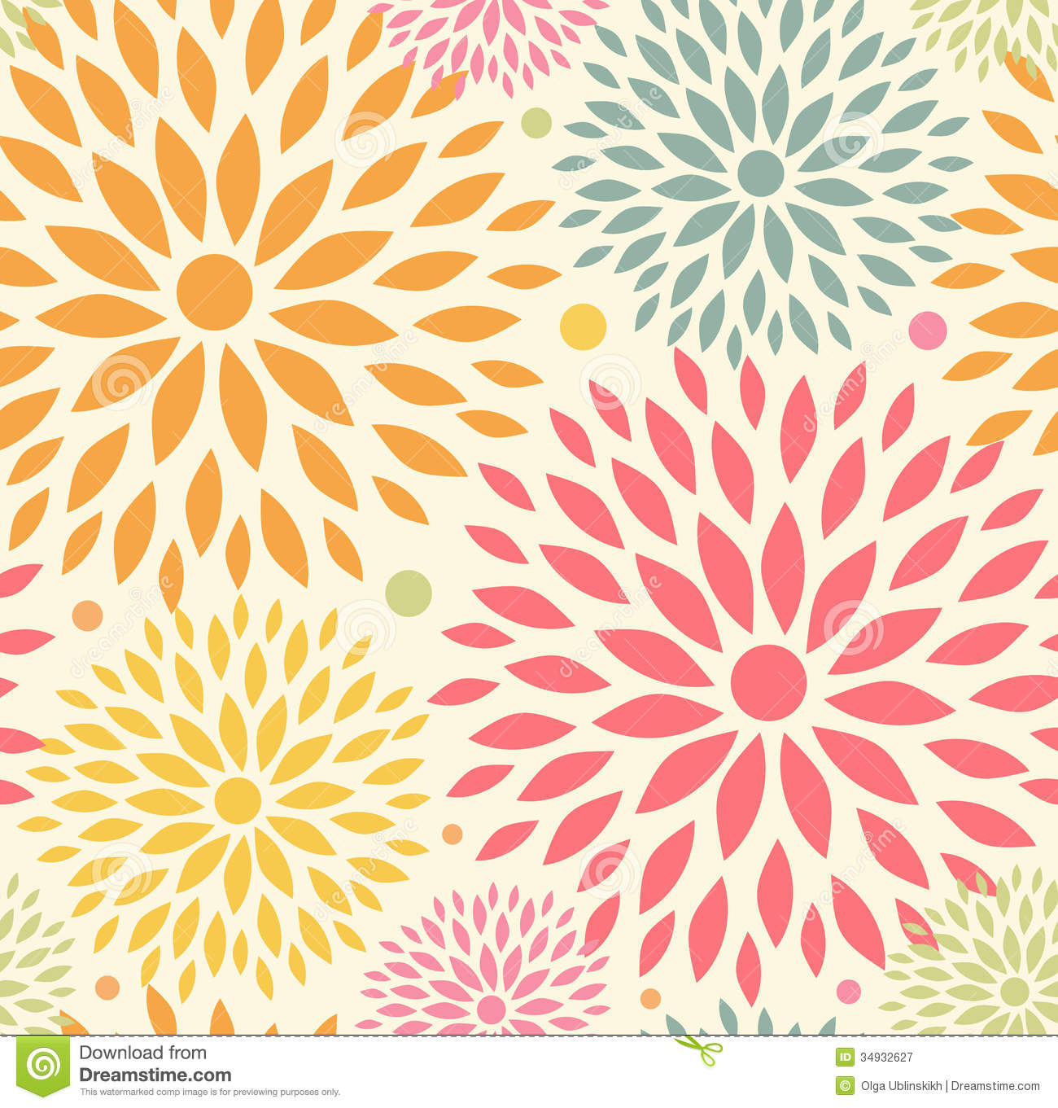

**Reminders:**

**Awards Chapel:**

**Wednesday, June 10th at 11am**

**(Your teacher will be emailing the link for this special Zoom meeting)**

**Thank you for all your hard work this school year!**

**Have a great summer!**

**What we are learning:**

**Spelling:**

-Review special sounds

-Write words in sentences

**Comprehension:**

- Use text evidence to answer questions

**Writing:**

- Construct complete sentences with appropriate capitalization and punctuation

**Mat**h:

-Review addition and subtraction computation skills

-Review time

-Review problem solving skills

**Scienc**e:

-Conduct simple home experiments

**Social Studies:**

-Complete“Countries of the World”

First Grade Goal Sheet

Mrs. Brooks

1stbrooks@mcaschools.org

June 2020

**Specials Classes:**

**Computers (Monday): Review week**

**Art (Tuesday): Review week**

**Music (Wednesday): NA**

**Spanish (Thursday): Review week**

**Gym (Friday): Review week**

**Following Jesus:**

**Bible**: Purposeful Design-Trusting and Believing God



**Chapel**: “Learn to Manage”

**Memory Verse**: Matthew 6:33

**Scripture Verse:**