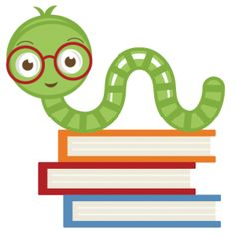

**Specials Classes:**

**Spanish (Monday):** Exposing the students to the Spanish language. The students will be learning feelings and adjectives in Spanish.

**Computers (Tuesday):** Continue emphasizing proper hand placement showing which fingers are responsible for which keys on the keyboard.

**Gym (Friday):** Students will learn teamwork, and cooperation along with the skill to play Flag Football.

**Reminders:**

Please make sure you are taking the papers out of your student’s “take home” folder each weekend and be sure to check google classroom daily.

Depending on the weather, please remember to pack a light jacket or sweater for your child.

**Easter Break – No School 4/2-4/11**

**Following Jesus:**

**Bible**: The Lord’s Prayer

**Chapel** **Attribute 6**: Learn to Pray

**Scripture Verse:** Matthew 6:9-13

**What we are learning:**

**Reading:** Long Vowels, Two Vowels Go Walking and Super E, Reading with fluency and expression, Spelling Words

**Writing**: Writing our own sentences, using spelling words in sentences

**Math**: Chapter 11 Measurement, Telling Time: Hour and Half Hour

**Science**: Plants

**Social Studies:** We will continue our “tour” around the world. We will be learning about other cultures. We will be talking about how God loves all the children of the world.

Kindergarten I Goal Sheet

Ms. Wiltsey

k1wiltsey@mcaschools.org

April 2021