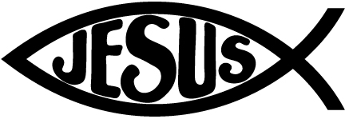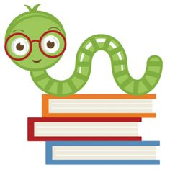

**Specials Classes:**

**Spanish (Monday):** Exposing the students to the Spanish language. The Students will be learning verbs in Spanish.

**Computers (Tuesday):** Continue emphasizing proper hand placement showing which fingers are responsible for which keys on the keyboard.

**Gym (Friday):** Prepping for field day, games hurdles relay race running throwing etc.

**Following Jesus:**

**Bible**: The Fruit of the Spirit

**Chapel**: Attribute 7 “Learn to Manage”

**Memory Verse:** Matthew 6:33

**National Day of Prayer 2021 Theme** *Now the Lord is the Spirit, and where the Spirit of the Lord is, there is liberty.2 Cor. 3:17* **Prayer Points:** Our Leaders Our country to submit to God and His authority Our nation to unite Our nation’s leaders to focus on liberty Our nation to be compassionate and understanding with one another Our nation to learn to respect life – ALL life

**Celebrating Diversity**: A Biblically based emphasis on emulating Christ's love for all. We will discuss how God views people of all nations and backgrounds and how we should as well. As Christians, we have an opportunity to demonstrate to a watching world what Kingdom-inspired action looks like. We will celebrate cultures around the world. We will highlight the value of people in our country and discuss great contributions of Immigrant-Americans.

**What we are learning:**

**Language Arts:**

Target Skill: Show comprehension about what was read, identify sequence of a story. Using problem solving abilities by finishing the story based off context clues/pictures/character’s feelings. Examples within Fiction/Non-Fiction. ABC order.

Spelling: Spell words using syllable rules. Apply use of root word, suffixes, and prefixes.

**Writing**:

Focus Trait: Apply phonics rules to complete dictation. Construct complete sentences with appropriate capitalization and punctuation.

**Math**:

-Counting on (1’s, 10’s, 100’s) Grouping by 10’s

-Problem Solving. Related Facts

**Science**:

Mystery Science. Epic Book Materials

**History:**

My America and My World

**Reminders:**

* Please help students:
  + practice their spelling words every night
  + complete Reading Logs and bring them in every Friday
  + **remember their take home folders every day.**
  + use the bathroom every morning before coming to school.

**May 3-7 Staff Appreciation Week**

**Monday May 31, Memorial Day- School Closed**

First Grade Goal Sheet

Mrs. Ferren

1stferren@mcaschools.org

May 2021